PAN ANALYTICAL
X’PERT POWDER XRD
POWDER DIFFRACTION
OPERATING MANUAL
Advanced Centre for Materials Science
IIT Kanpur
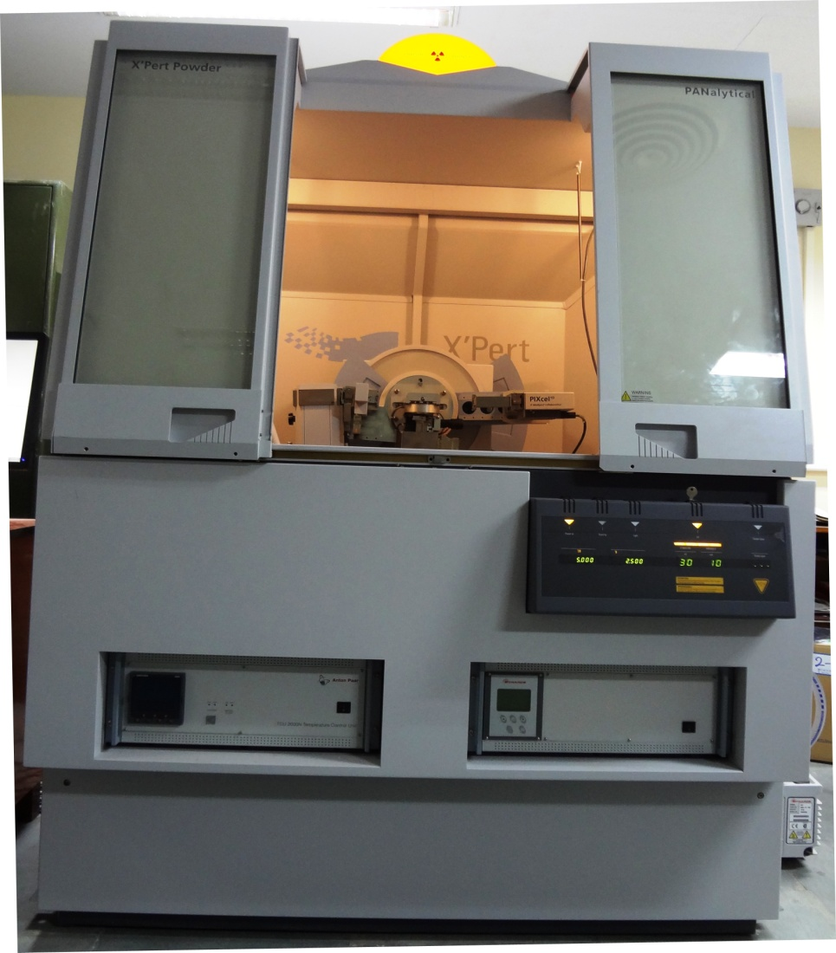

Operating Facility Convener
Dr. Nilesh Prakash Gurao
Assistant Professor
MSE Department, IIT Kanpur
Operating procedure for Powder Diffraction mode
- Install powder diffraction optics on the i.e. Programmable Divergent slit, Antiscattered slit, mask, solar slit on the incident beam side, Detector (pixel 1D), Antiscattered slit, solar slit on the diffracted beam side.
- Switch on Chiller MCB (in side cabin attached to XRD room) then set the temperature of chiller at 18°C.
- Power on XRD Machine MCB (on backside wall of the XRD machine)
- Power ON diffractometer (press the button o the XRD Panel)
- Turn the Key (on Diffractometer) quarter clockwise. (wait for few minutes to initialise the machine, default voltage and current values 30kV and 10mA will appear)
- Start the computer, Open Data collector software on the computer screen. Following window will appear

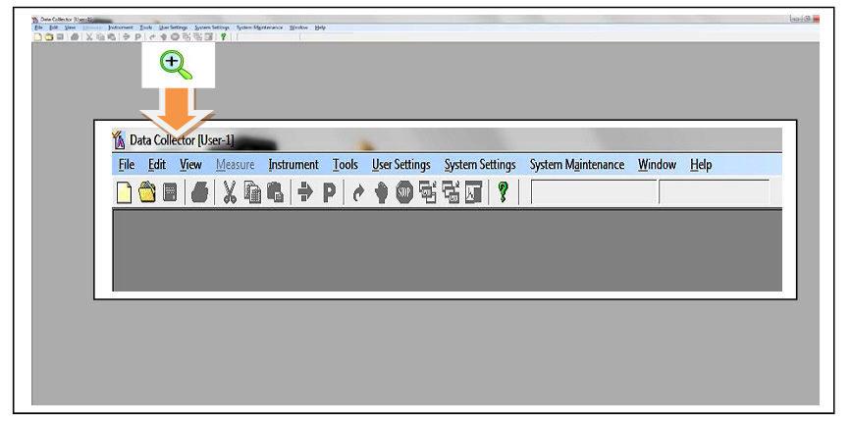
- Go to Instrument and connect
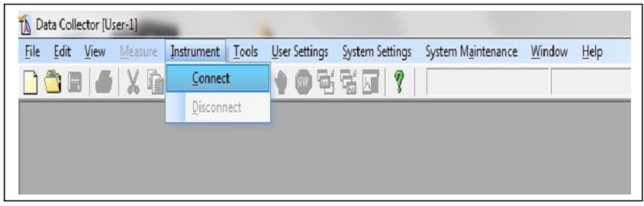
- Following message will appear click on OK.
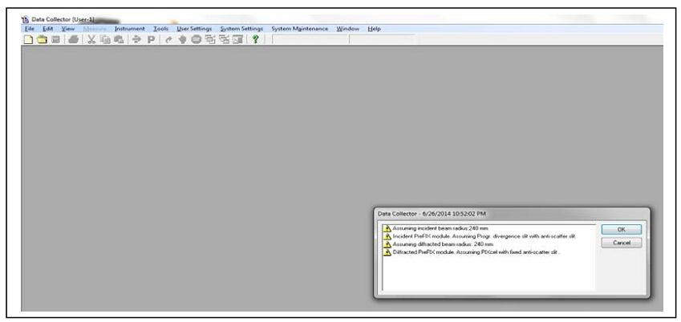

- Following window will appear
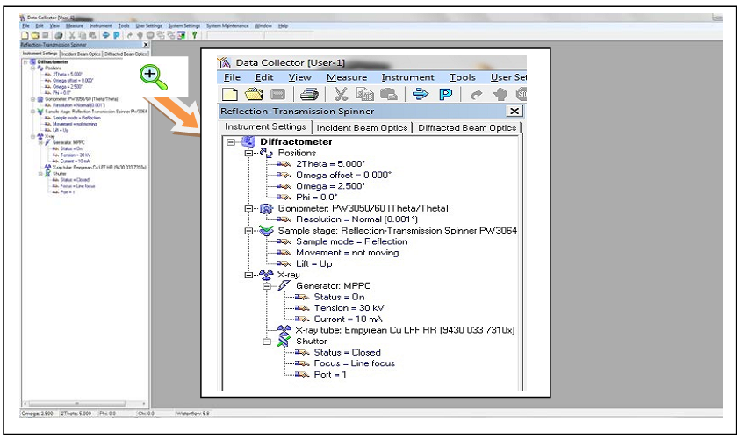

- Go to Incident beam optics and double click on incident beam path following window will appear
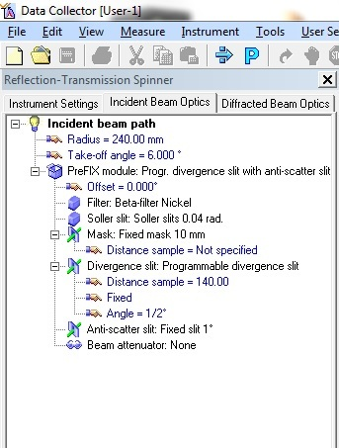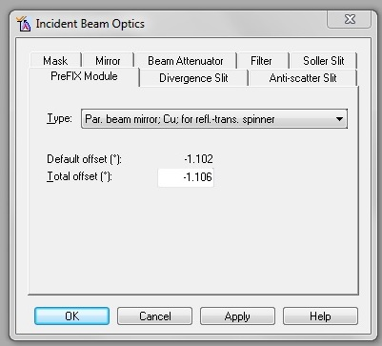

- Select the following parameters (Making of new Programme)
  - Prefix mode: Absolute scan
  - Setting : Generating MPPC For Bracket = not moving
For Reflection transmission
  - Programmable Divergence slit: 1°
Automatic mode= Area of sample fixed
Fixed mode= Divergent slit fixed
  - Beam attenuator: None
  - Mask: 10 mm
  - Antiscatter Slit: 1°
  - Mirror: None
  - Press Apply then OK.
- Go to Diffracted beam optics and double click on diffracted beam path1 following window will appear
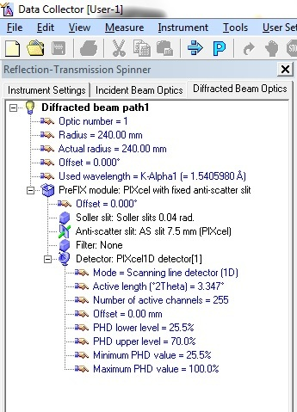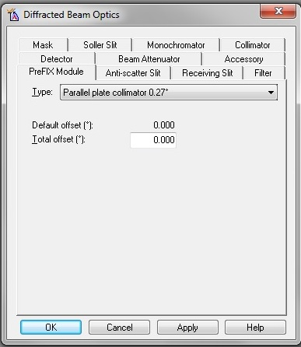

- Select the following parameters
  - PreFIX Module: Pixel with fixed antiscattered slit
  - Offset:0.00
  - Filter: none
  - Solar Slit: 0.04 rad
  - Antiscattered Slit: 7.5 mm
  - Detector Type: Pixcel 1D Detector[1]
  - Receiving Slit: 0D
  - Active length: 3.347
  - Active channels: 255
  - Used wavelength = K-Alpha1
  - Beam Attanuator: None
  - Collimator: None
  - Mask: None
  - Monochromator: None
  - Receiving Slit: None
  - Press Apply then OK.
  - Save in My Computer (XRD Data)
- Go to user setting and select sample offset
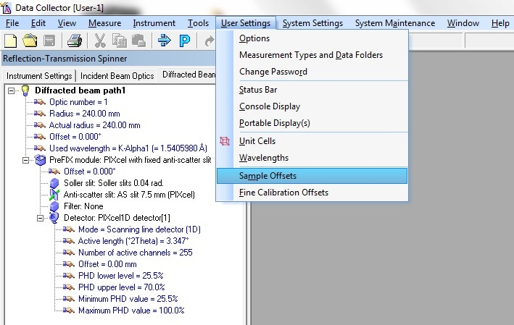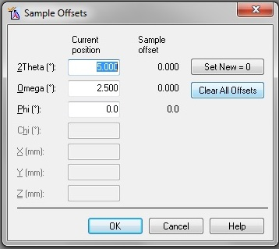

  - Clear all offset
  - Press OK
- Go to instrument setting double click on position following window will appear
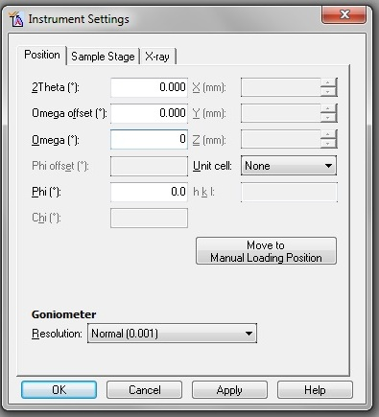
Make the following entries
  - 2theta: 0
  - Omega: 0
  - Omega offset: 0
  - Phi: 0
  - Press Apply then OK.

- Go to Manual Scan following window will appear
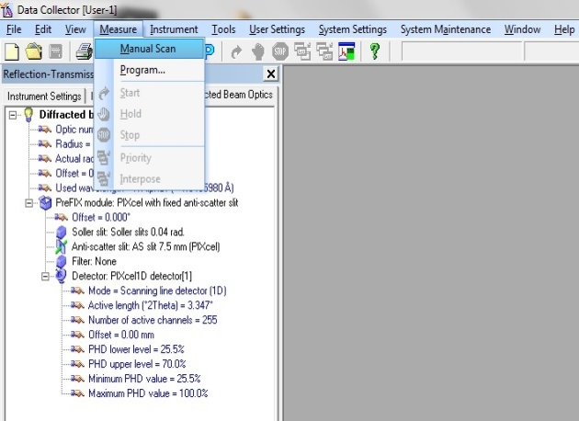

  - 2theta: required for your sample.
  - Step Size: required for your sample.
  - Time per Step: required for your sample.
  - Then Apply and Ok
- Connect the Programme
  - Go to Instrument
  - Double click on sample stage reflection and select sample stage
  - Untick Lift Up
  - Mount the sample
  - Tick Lift Up
  - Click on Apply then OK.
- Go to Measure and click on Program the following window will appear
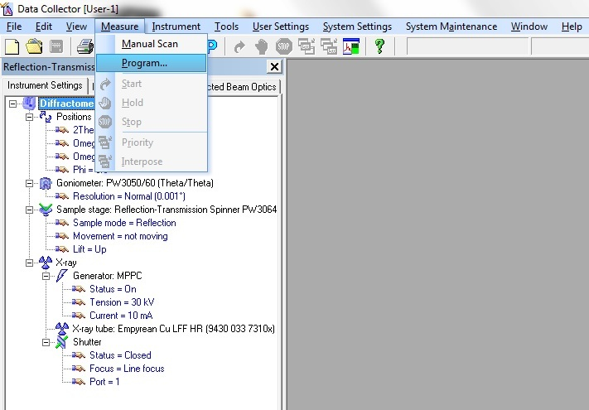
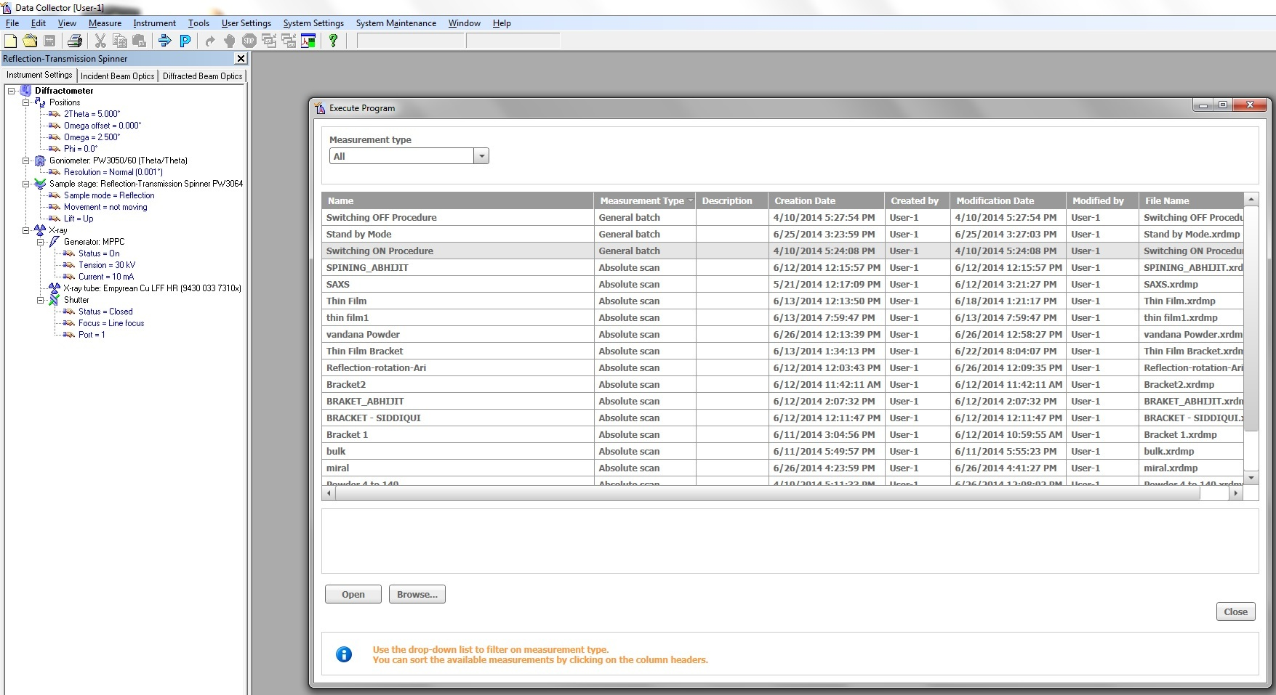

  - Select Switching ON Procedure (to increase voltage to 45kV and current to 40 mA)
  - Click on Open
  - Start then OK
- Again go to Measure click on Program
  - Select your specified Program
  - Click on Open
  - Give the location to the scanned file.
- Scan will start and will be saved automatically to your mentioned destination.
- After scan go to Measure click on Program
  - Select switching OFF Procedure (to decrease the voltage and current to 0kV and 0mA)
  - Click to Open
- Go to Instrument select Disconnect.
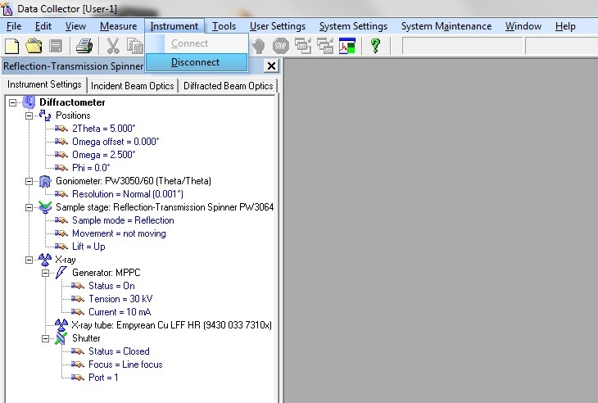
- Close the Data Collector software.
- Press Standby button on Diffractometer.
- Move the key quarter Anticlock wise.
- Switch OFF the MCB (on the backside wall of the Machine)
- Switch OFF the Chiller MCB.
- Switch OFF the Computer.
- Make the Entry in the Register.

